- Read/ write the Local data.
https://www.tutorialspoint.com/android/android_internal_storage.htm
Internal Storage Android - W3schools

STRUCTURE OF A PROGRAM:

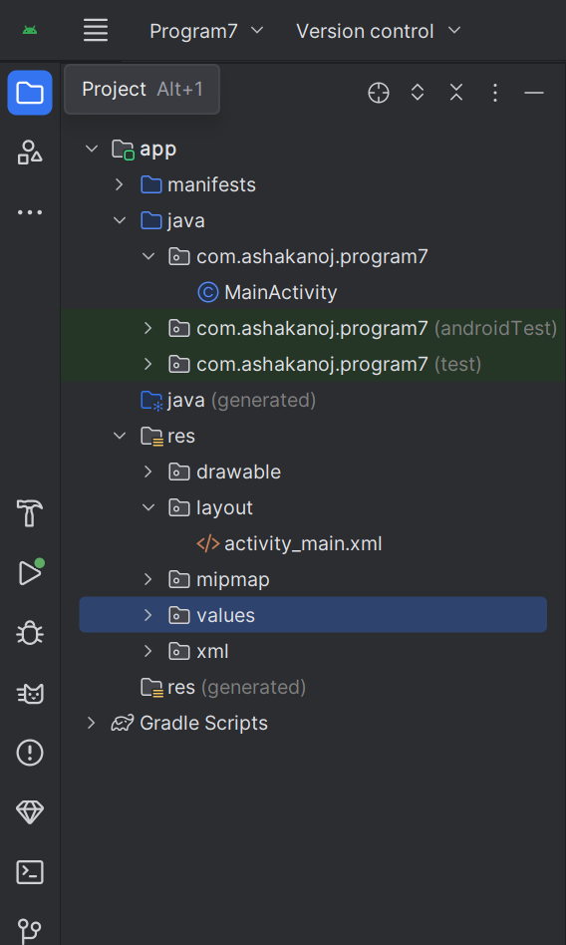

activity_main.xml File:

<?xml version="1.0" encoding="utf-8"?>
<RelativeLayout xmlns:android="http://schemas.android.com/apk/res/android"
xmlns:tools="http://schemas.android.com/tools"
android:layout_width="match_parent"
android:layout_height="match_parent"
android:paddingTop="@dimen/activity_vertical_margin"
android:background="@color/black"
tools:context=".MainActivity" >
<EditText
android:id="@+id/editText1"
android:layout_width="wrap_content"
android:layout_height="wrap_content"
android:layout_alignParentTop="true"
android:layout_alignParentRight="true"
android:layout_marginTop="134dp"
android:layout_marginRight="19dp"
android:textColor="@color/white"
android:ems="10">
<requestFocus />
</EditText>
<EditText
android:id="@+id/editText2"
android:layout_width="wrap_content"
android:layout_height="wrap_content"
android:layout_alignRight="@+id/editText1"
android:layout_below="@+id/editText1"
android:layout_marginTop="24dp"
android:textColor="@color/white"
android:ems="10" />
<TextView
android:id="@+id/textView1"
android:layout_width="wrap_content"
android:layout_height="wrap_content"
android:layout_alignBaseline="@+id/editText1"
android:layout_alignBottom="@+id/editText1"
android:layout_alignParentLeft="true"
android:textColor="@color/white"
android:text="Enter File Name:" />
<TextView
android:id="@+id/textView2"
android:layout_width="wrap_content"
android:layout_height="wrap_content"
android:layout_alignBaseline="@+id/editText2"
android:layout_alignBottom="@+id/editText2"
android:layout_alignParentLeft="true"
android:textColor="@color/white"
android:text=" Enter Information to Read:" />
<Button
android:id="@+id/button1"
android:layout_width="wrap_content"
android:layout_height="wrap_content"
android:layout_alignLeft="@+id/editText2"
android:layout_below="@+id/editText2"
android:layout_marginLeft="50dp"
android:layout_marginTop="16dp"
android:text="Save" />
<Button
android:id="@+id/button2"
android:layout_width="wrap_content"
android:layout_height="wrap_content"
android:layout_alignBaseline="@+id/button1"
android:layout_alignBottom="@+id/button1"
android:layout_toRightOf="@+id/button1"
android:text="Read" />
</RelativeLayout>

MainActivity.xml File:

package com.ashakanoj.program7;
import android.content.Context;
import android.os.Bundle;
import android.view.View;
import android.widget.Button;
import android.widget.EditText;
import android.widget.Toast;
import androidx.appcompat.app.AppCompatActivity;
import java.io.BufferedReader;
import java.io.FileNotFoundException;
import java.io.FileOutputStream;
import java.io.IOException;
import java.io.InputStreamReader;
public class MainActivity extends AppCompatActivity {
EditText editTextFileName,editTextData;
Button saveButton,readButton;
@Override
protected void onCreate(Bundle savedInstanceState) {
super.onCreate(savedInstanceState);
setContentView(R.layout.activity_main);
editTextFileName=findViewById(R.id.editText1);
editTextData=findViewById(R.id.editText2);
saveButton=findViewById(R.id.button1);
readButton=findViewById(R.id.button2);
//Performing Action on Read Button
saveButton.setOnClickListener(new View.OnClickListener(){
@Override
public void onClick(View arg0) {
String filename=editTextFileName.getText().toString();
String data=editTextData.getText().toString();
FileOutputStream fos;
try {
fos = openFileOutput(filename, Context.MODE_PRIVATE);
//default mode is PRIVATE, can be APPEND etc.
fos.write(data.getBytes());
fos.close();
Toast.makeText(getApplicationContext(),filename + " stored",
Toast.LENGTH_LONG).show();
} catch (FileNotFoundException e) {e.printStackTrace();}
catch (IOException e) {e.printStackTrace();}
}
});

//Performing Action on Read Button
readButton.setOnClickListener(new View.OnClickListener(){
@Override
public void onClick(View arg0) {
String filename=editTextFileName.getText().toString();
StringBuffer stringBuffer = new StringBuffer();
try {
//Attaching BufferedReader to the FileInputStream by the help of InputStreamReader
BufferedReader inputReader = new BufferedReader(new InputStreamReader(
openFileInput(filename)));
String inputString;
//Reading data line by line and storing it into the stringbuffer
while ((inputString = inputReader.readLine()) != null) {
stringBuffer.append(inputString + "\n");
}
} catch (IOException e) {
e.printStackTrace();
}
//Displaying data on the toast
Toast.makeText(getApplicationContext(),stringBuffer.toString(),Toast.LENGTH_LONG).show();
}
});
}
}

Output:
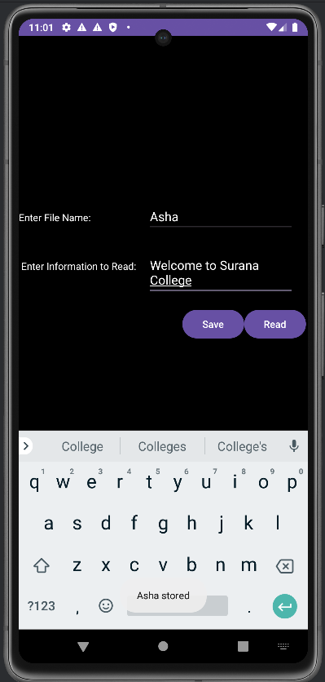
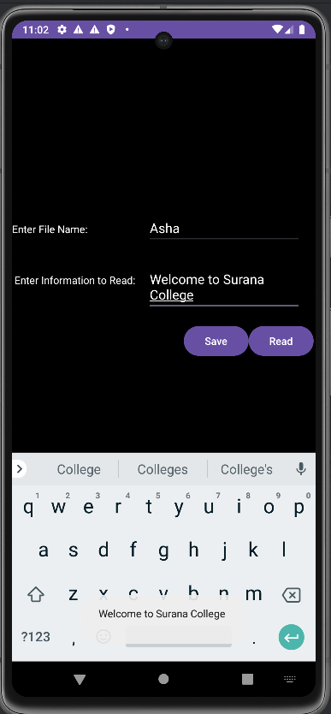
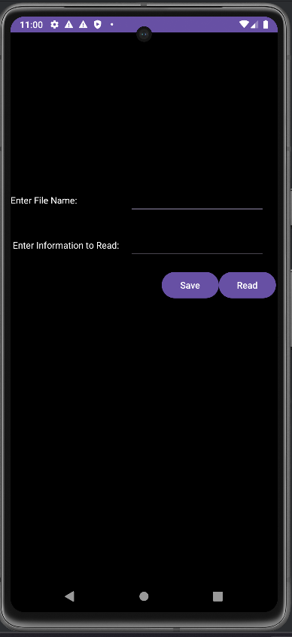

- Create an application to send SMS.

https://www.tutorialspoint.com/android/android_sending_sms.htm
https://www.geeksforgeeks.org/sending-a-text-message-over-the-phone-using-smsmanager-in-android/
https://www.geeksforgeeks.org/implement-phone-number-validator-in-android/

STRUCTURE OF A PROGRAM:
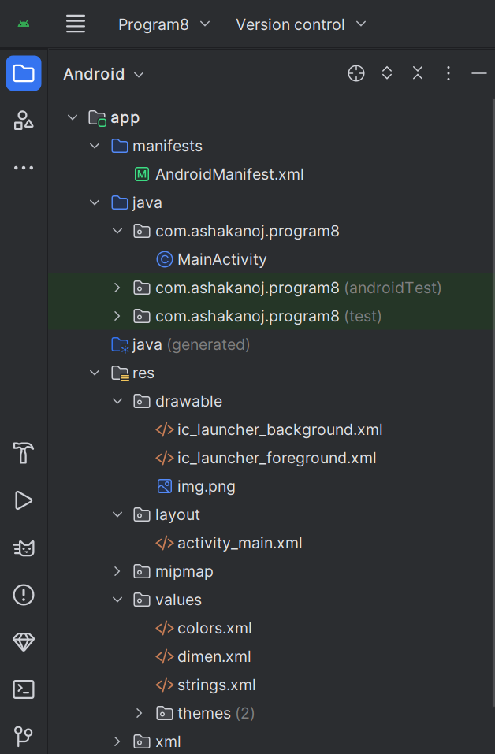

Androidmanifest.xml File:

<?xml version="1.0" encoding="utf-8"?>
<manifest xmlns:android="http://schemas.android.com/apk/res/android"
xmlns:tools="http://schemas.android.com/tools">
<uses-permission android:name="android.permission.SEND_SMS"/>
<uses-feature android:name="android.hardware.telephony" android:required="false" />
<uses-permission android:name="android.permission.READ_PHONE_STATE"/>
<application
android:allowBackup="true"
android:dataExtractionRules="@xml/data_extraction_rules"
android:fullBackupContent="@xml/backup_rules"
android:icon="@mipmap/ic_launcher"
android:label="@string/app_name"
android:roundIcon="@mipmap/ic_launcher_round"
android:supportsRtl="true"
android:theme="@style/Theme.SMS"
tools:targetApi="31">
<activity
android:name=".MainActivity"
android:exported="true">
<intent-filter>
<action android:name="android.intent.action.MAIN" />
<category android:name="android.intent.category.LAUNCHER" />
</intent-filter>
</activity>
</application>
</manifest>

Activity_main.xml File:

<?xml version="1.0" encoding="utf-8"?>
<LinearLayout xmlns:android="http://schemas.android.com/apk/res/android"
android:layout_width="match_parent"
android:layout_height="match_parent"
android:padding="20dp"
android:background="@color/pink"
android:orientation="vertical">
<EditText
android:id="@+id/phoneNumber"
android:layout_width="match_parent"
android:layout_height="wrap_content"
android:hint="Enter Phone Number"
android:inputType="phone"/>
<EditText
android:id="@+id/message"
android:layout_width="match_parent"
android:layout_height="wrap_content"
android:hint="Enter Message"
android:inputType="textMultiLine"
android:minHeight="100dp"/>
<Button
android:id="@+id/sendSMS"
android:layout_width="match_parent"
android:layout_height="wrap_content"
android:text="Send SMS"
android:layout_marginTop="20dp"/>
</LinearLayout>

MainActivity.java File:

package com.asha.sms;
import android.Manifest;
import android.content.pm.PackageManager;
import android.os.Bundle;
import android.telephony.SmsManager;
import android.view.View;
import android.widget.Button;
import android.widget.EditText;
import android.widget.Toast;
import androidx.annotation.NonNull;
import androidx.appcompat.app.AppCompatActivity;
import androidx.core.app.ActivityCompat;
import androidx.core.content.ContextCompat;
public class MainActivity extends AppCompatActivity {
EditText phoneNumber, message;
Button sendSMS;
private static final int SMS_PERMISSION_CODE = 101;
@Override
protected void onCreate(Bundle savedInstanceState) {
super.onCreate(savedInstanceState);
setContentView(R.layout.activity_main);
// Initialize UI components
phoneNumber = findViewById(R.id.phoneNumber);
message = findViewById(R.id.message);
sendSMS = findViewById(R.id.sendSMS);
// Button click listener
sendSMS.setOnClickListener(new View.OnClickListener() {
@Override
public void onClick(View v) {
if (checkSmsPermission()) {
sendSms();
} else {
requestSmsPermission();
}
}
});
}
// Method to send SMS with validation
private void sendSms() {
String number = phoneNumber.getText().toString().trim();
String msg = message.getText().toString().trim();
// Validate phone number
if (number.isEmpty()) {
Toast.makeText(this, "Please enter a phone number", Toast.LENGTH_SHORT).show();
return;
}
if (!number.matches("\\d{10}")) {
Toast.makeText(this, "Enter a valid 10-digit phone number", Toast.LENGTH_SHORT).show();
return;
}
// Validate message content
if (msg.isEmpty()) {
Toast.makeText(this, "Please enter a message", Toast.LENGTH_SHORT).show();
return;
}
try {
SmsManager smsManager = SmsManager.getDefault();
smsManager.sendTextMessage(number, null, msg, null, null);
Toast.makeText(this, "SMS Sent Successfully!", Toast.LENGTH_SHORT).show();
} catch (Exception e) {
Toast.makeText(this, "SMS Sending Failed!", Toast.LENGTH_SHORT).show();
e.printStackTrace();
}
}
// Check SMS permission
private boolean checkSmsPermission() {
return ContextCompat.checkSelfPermission(this, Manifest.permission.SEND_SMS) == PackageManager.PERMISSION_GRANTED;
}
// Request SMS permission
private void requestSmsPermission() {
ActivityCompat.requestPermissions(this, new String[]{Manifest.permission.SEND_SMS}, SMS_PERMISSION_CODE);
}
// Handle permission result
@Override
public void onRequestPermissionsResult(int requestCode, @NonNull String[] permissions, @NonNull int[] grantResults) {
super.onRequestPermissionsResult(requestCode, permissions, grantResults);
if (requestCode == SMS_PERMISSION_CODE) {
if (grantResults.length > 0 && grantResults[0] == PackageManager.PERMISSION_GRANTED) {
sendSms();
} else {
Toast.makeText(this, "Permission Denied! Cannot send SMS.", Toast.LENGTH_SHORT).show();
}
}
}
}

Output:

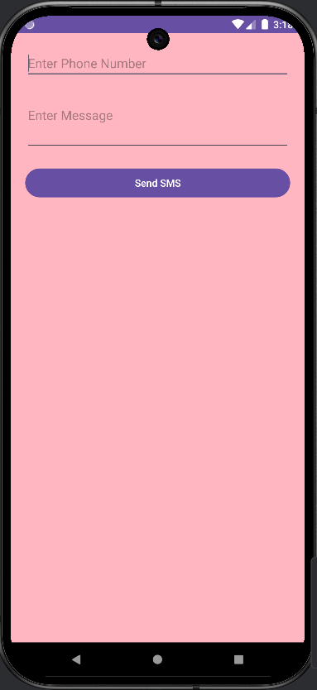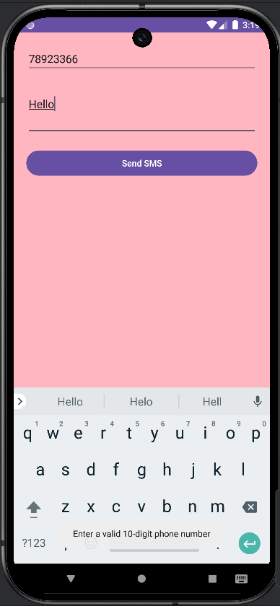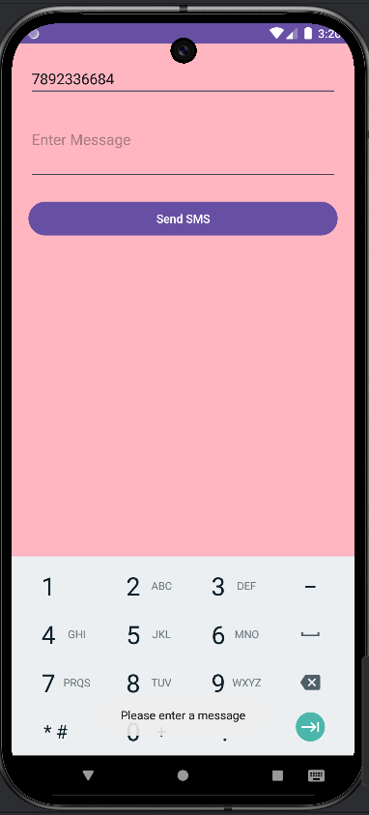

Go to SMS Widget in the Virtual Device and click on Icon given below:

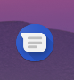

You can view the received SMS as shown below.
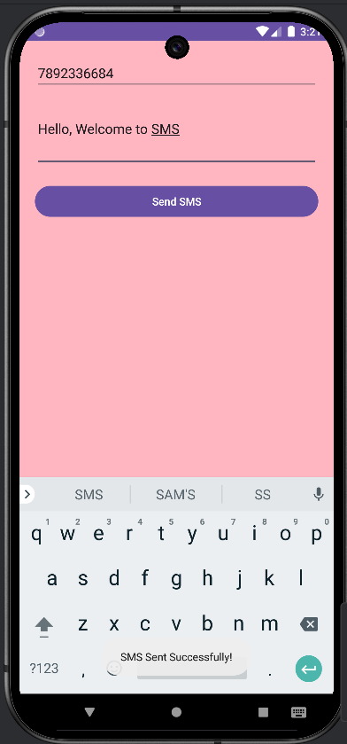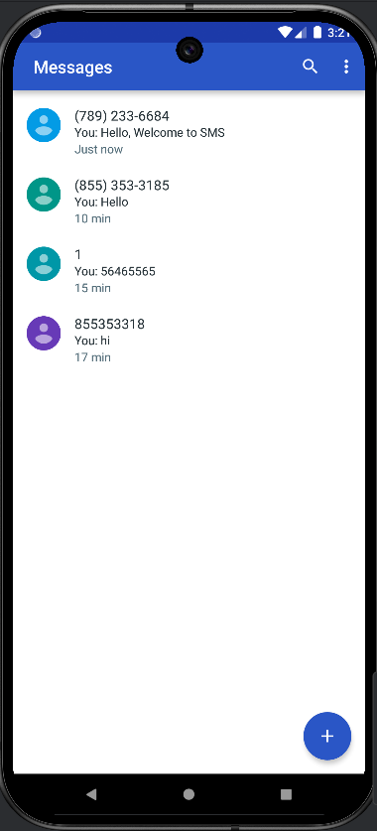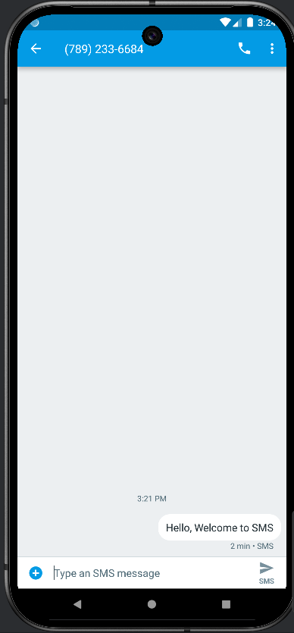

- Create an application to send an e-mail.

STRUCTURE OF A PROGRAM:

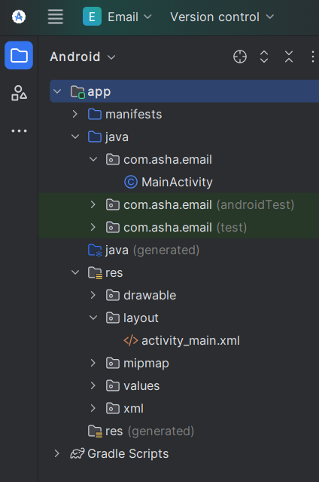

activity_main.xml File:

<?xml version="1.0" encoding="utf-8"?>
<LinearLayout xmlns:android="http://schemas.android.com/apk/res/android"
android:layout_width="match_parent"
android:layout_height="match_parent"
android:padding="20dp"
android:orientation="vertical">
<EditText
android:id="@+id/emailTo"
android:layout_width="match_parent"
android:layout_height="wrap_content"
android:hint="Enter recipient email"
android:inputType="textEmailAddress"/>
<EditText
android:id="@+id/emailSubject"
android:layout_width="match_parent"
android:layout_height="wrap_content"
android:hint="Enter subject"
android:inputType="text"/>
<EditText
android:id="@+id/emailMessage"
android:layout_width="match_parent"
android:layout_height="wrap_content"
android:hint="Enter message"
android:inputType="textMultiLine"
android:minHeight="100dp"/>
<Button
android:id="@+id/sendEmail"
android:layout_width="match_parent"
android:layout_height="wrap_content"
android:text="Send Email"
android:layout_margin="10dp"/>
</LinearLayout>

MainActivity.java File:

package com.asha.email;
import android.content.Intent;
import android.net.Uri;
import android.os.Bundle;
import android.view.View;
import android.widget.Button;
import android.widget.EditText;
import android.widget.Toast;
import androidx.appcompat.app.AppCompatActivity;
public class MainActivity extends AppCompatActivity {
EditText emailTo, emailSubject, emailMessage;
Button sendEmail;
@Override
protected void onCreate(Bundle savedInstanceState) {
super.onCreate(savedInstanceState);
setContentView(R.layout.activity_main);
// Initialize UI components
emailTo = findViewById(R.id.emailTo);
emailSubject = findViewById(R.id.emailSubject);
emailMessage = findViewById(R.id.emailMessage);
sendEmail = findViewById(R.id.sendEmail);
// Button click listener
sendEmail.setOnClickListener(new View.OnClickListener() {
@Override
public void onClick(View v) {
sendEmail();
}
});
}
// Method to send email
private void sendEmail() {
String recipient = emailTo.getText().toString().trim();
String subject = emailSubject.getText().toString().trim();
String message = emailMessage.getText().toString().trim();
// Validate input
if (recipient.isEmpty()) {
Toast.makeText(this, "Please enter recipient email", Toast.LENGTH_SHORT).show();
return;
}
if (!android.util.Patterns.EMAIL_ADDRESS.matcher(recipient).matches()) {
Toast.makeText(this, "Enter a valid email address", Toast.LENGTH_SHORT).show();
return;
}
if (subject.isEmpty()) {
Toast.makeText(this, "Please enter a subject", Toast.LENGTH_SHORT).show();
return;
}
if (message.isEmpty()) {
Toast.makeText(this, "Please enter a message", Toast.LENGTH_SHORT).show();
return;
}
// Open email app with pre-filled details
Intent intent = new Intent(Intent.ACTION_SENDTO);
intent.setData(Uri.parse("mailto:" + recipient));
intent.putExtra(Intent.EXTRA_SUBJECT, subject);
intent.putExtra(Intent.EXTRA_TEXT, message);
try {
startActivity(Intent.createChooser(intent, "Choose an Email Client"));
} catch (Exception e) {
Toast.makeText(this, "No email client installed", Toast.LENGTH_SHORT).show();
}
}
}

Output:

